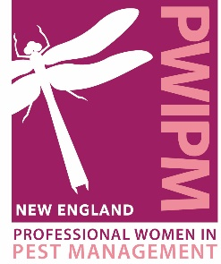
New England Women of Excellence Award
The regional honor is open to women across the pest management industry – PMP’s, manufacturers, research organizations, etc. who have demonstrated outstanding leadership and have made notable contributions to the development and growth of the profession and their companies. Nominees may be nominated by more than one person. Nominees should reside and/or work in at least one of the New England States: Connecticut, Maine Massachusetts, New Hampshire, Rhode Island, or Vermont.
Send completed forms (in Word format) to: nepma@pestworld.org by February 1st
The judging process is double-blind. All nominations are stripped of any identifying information (name, location, company affiliation, etc.) and put into a scoring sheet. Judges score the nominations based on the following criteria and weights:
- Service to industry: 50%
- Service to company: 25%
- Service to the community and other women: 25%
The New England Women of Excellence Award is presented at the Annual Awards Dinner in March, in conjunction with Spring Training.
NOMINATION FORM
Your Name:
Your E-mail:
Your Phone:
Your Company:
Candidate Name:
Candidate Company Name:
Candidate E-mail:
Candidate Phone:
Please describe the nominee’s contributions to the industry:

Please offer illustration of the nominee’s leadership contributions to her company.

Please describe examples of the nominee’s personal leadership and community involvement and stewardship.

Please use this space to offer any additional reasons or illustrations of why the nominee should be considered for PWIPM of New England Women of Excellence Award.

